FlightSurveyReadme

Tests

SOMETIMES TESTS ARE FAILING

can withdraw

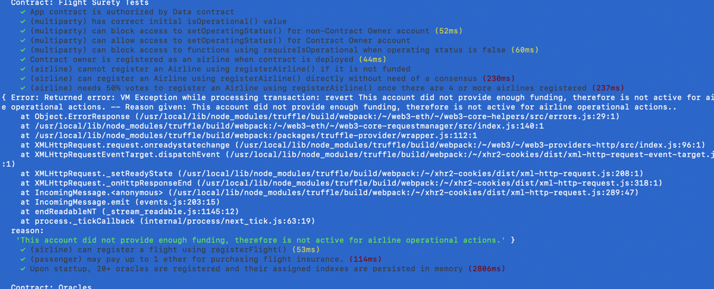any fun

A Dapp client has been created and is used for triggering contract calls. Client can be launched with “npm run dapp” and is available at [http://localhost:8000](http://localhost:8000/)

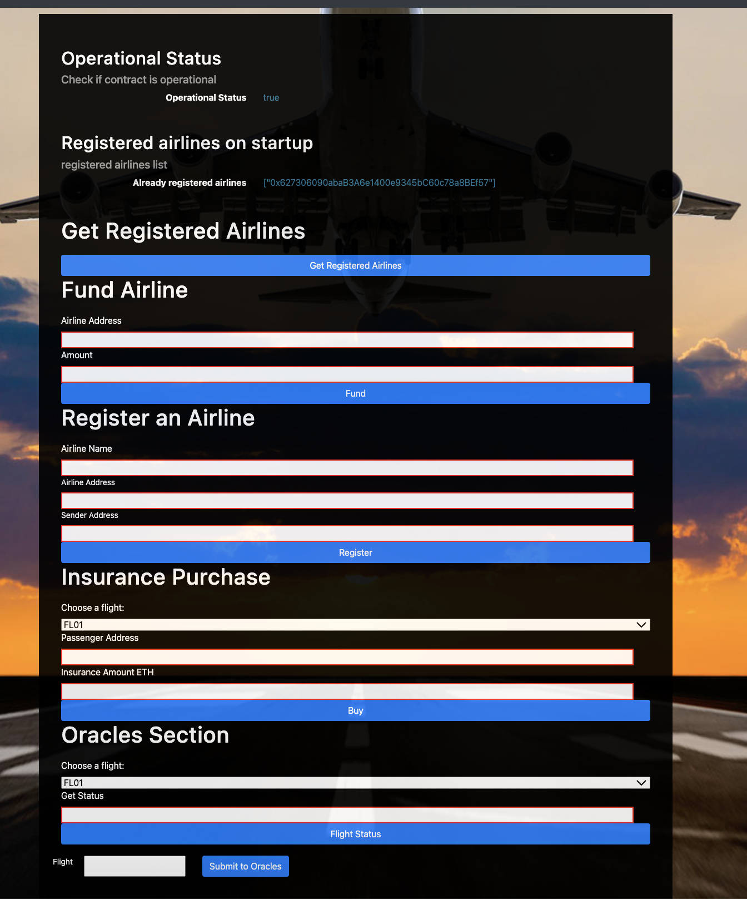ds owe

1. Passenger can purchase insurance for flight

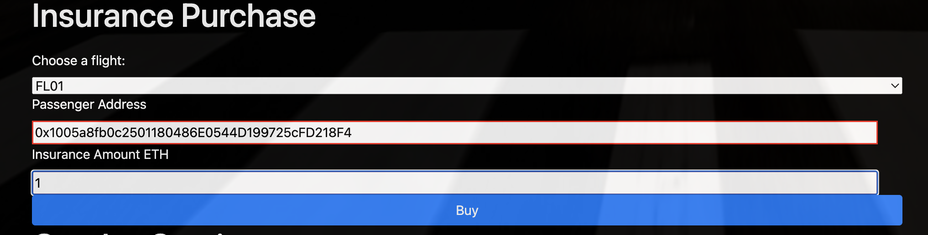

WHEN AMOUNT IS MORE THEN 1 ETH

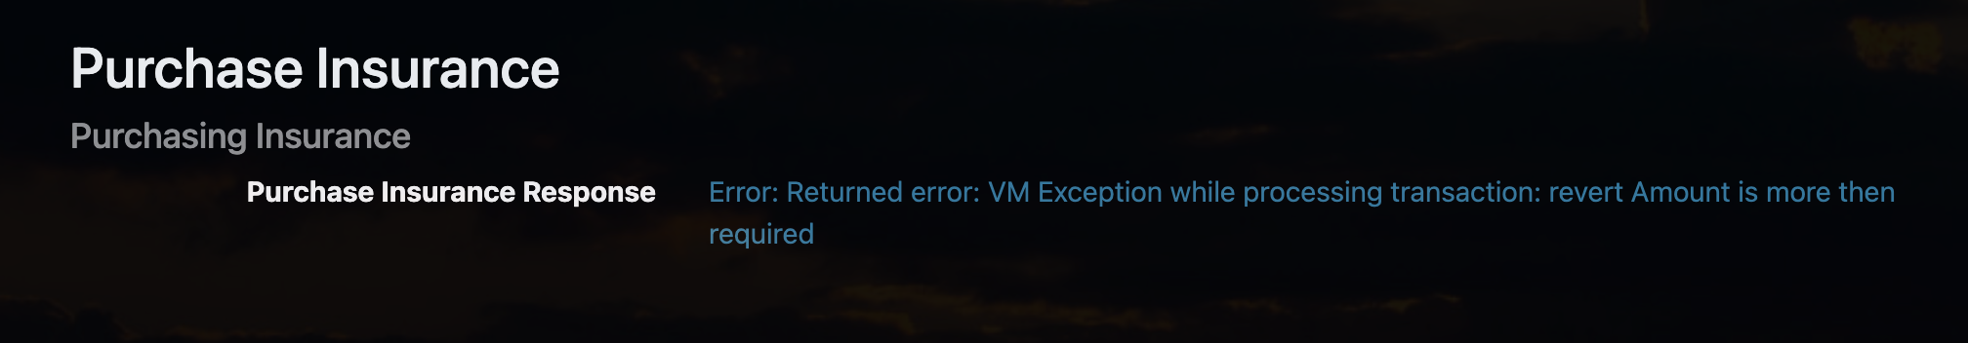

WHEN AMOUNT IS LESS THE 1 ETH

2) Trigger contract to request flight status update

them as a result

Oracle Server Application

A server app has been created for simulating oracle behavior.

Server can be launched with “npm run server

|  |  |
| --- | --- |
| Operational status control is implemented in contracts | Students has implemented operational status control. |

|  |  |
| --- | --- |
| Fail Fast Contract | Contract functions “fail fast” by having a majority of “require()” calls at the beginning of function body |

|  |  |
| --- | --- |
| Airline Contract Initialization | First airline is registered when contract is deployed. |

Multiparty Consensus

Only existing airline may register a new airline until there are at least four airlines registered

Demonstrated either with Truffle test or by making call from client Dapp

Airline Ante

Airline can be registered, but does not participate in contract until it submits funding of 10 ether (make sure it is not 10 wei)

Demonstrated either with Truffle test or by making call from client Dapp

Passenger Airline Choice

Passengers can choose from a fixed list of flight numbers and departures that are defined in the Dapp client

Your UI implementation should include:

Fields for Airline Address and Airline Name

Amount of funds to send/which airline to send to

Ability to purchase flight insurance for no more than 1 ether



Passenger Payment

Passengers may pay up to 1 ether for purchasing flight insurance.



Functioning Oracle

Oracle functionality is implemented in the server app.

Oracle Initialization

Upon startup, 20+ oracles are registered and their assigned indexes are persisted in memory

Oracle Updates

Update flight status requests from client Dapp result in OracleRequest event emitted by Smart Contract that is captured by server (displays on console and handled in code)

